**Testing plan of ICT Inventory Project- Manual Unit testing.**

1. Login Functionality:

**1.0.1 Objective:** The objective of the test is to ensure that login functionality brings the user to the main page or dashboard of the system which has all the menus of the system.

* + 1. Features/Scope: The login interface pops up when you click on the launch app button, this shows that the button works. I decided to check for invalid and valid credentials and their error messages
    2. **Test cases/scenarios:**

**1.0.4 Case1:** Upon entering the valid credentials, and clicking on the login button

* + 1. **Expected Result/actual:** Successful login

**E**ntering the right credentials brings you to the home page of the system as shown below

1.0.6 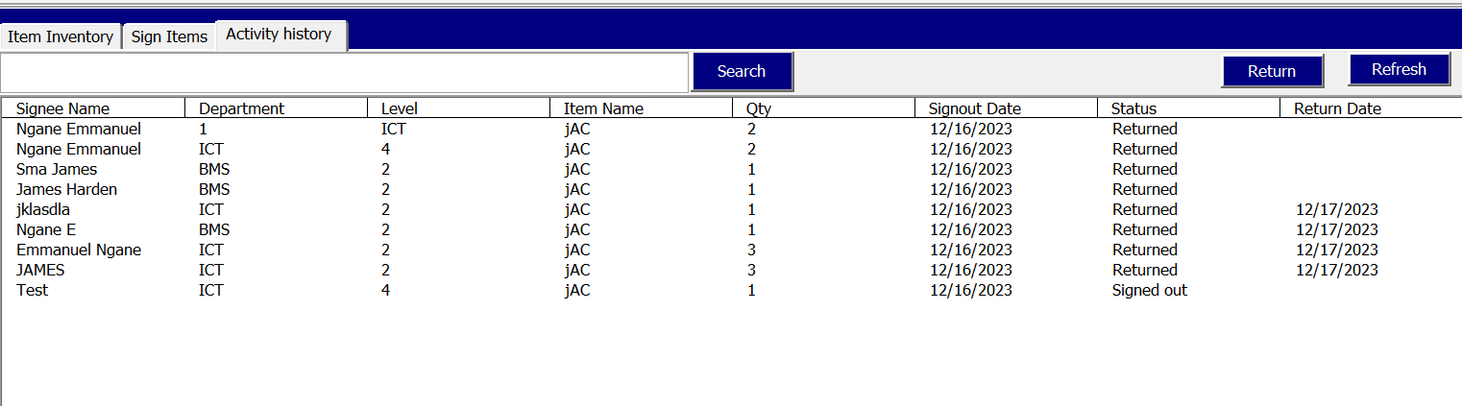

**Result: Login test passed.**

**1.0.7 Case2:** Entering anything otherwise or leaving it blank.

* + 1. **Expected Result/actual:** Wrong credentials

1.0.9 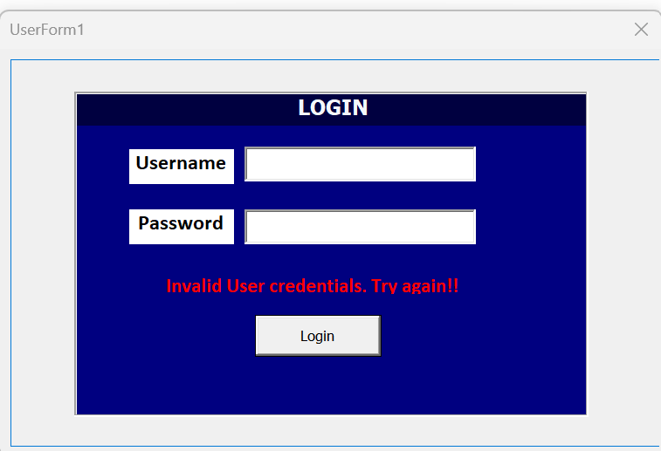

1. **Add Item functionality**

**T**his functionality can be divided into 2 sub units: The bringing up of a contextual menu where Items will be added and the successful adding of the item in the database

2.1: Subunit1: Testing Pop-up Display

**2.1.1 Objective: T**he objective of this subunit is to verify that the pop up is displayed correctly when add button is clicked

* + 1. **Scope:** Testing if menu comes up when button is clicked
    2. **Test Cases:**
    3. **Case1:** Upon clicking the add button
    4. **Expected Result/actual:** Successful display of the add menu with all its content.

**2.1.6**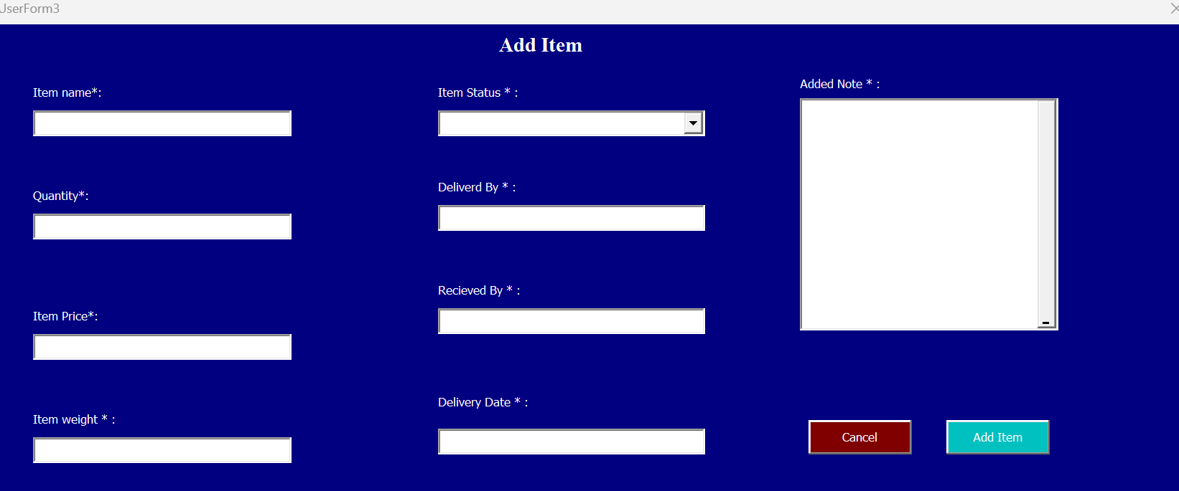

* 1. **Subunit 2: Testing adding of item.**

**2.2.1 Objective: T**he objective of this subunit is to verify if items are added successfully into the database

* + 1. **Scope:** Testing adding of new item with missing data, Testing addition of item to the inventory

**Test Cases/scenarios:**

* + 1. **Case1:** Adding data item with missing data
    2. **Expected Result:** message box showing unfilled data
    3. **Actual Result: item were still added with missing fields**
    4. **Case2:** Adding item with all fields:
    5. **Expected Result/actual:** Successful adding of the item.

**2.2.8**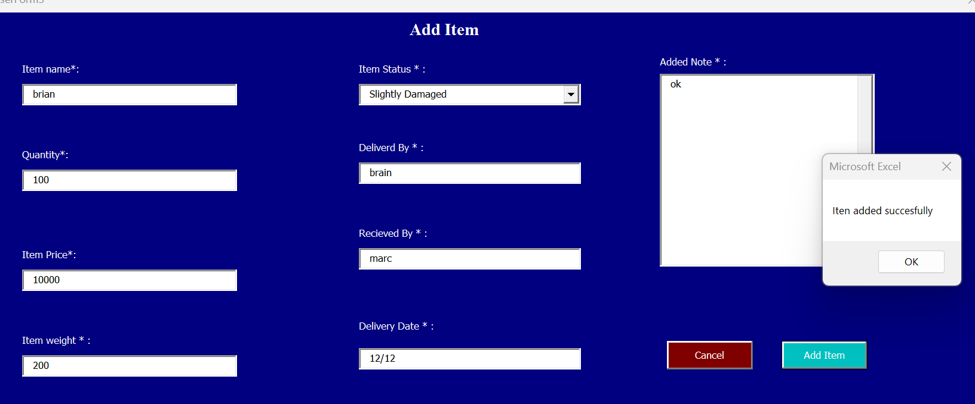

Also items are added in the inventory successfully.

2.2.9

**From the testing of this functionality**, we see we could actually put gibberish into the fields, and also leave some fields empty.

Indicating a loop hole in the system.

**Test result : Expected result not accomplished!.**

**3 Edit Functionality:**

**3.1.0 Subunit 1: Testing the popping up of the menu with predefined fields displayed**

**3.1.1 Objective: The objective of t**o verify that the menus pops up correctly with the fields already displayed

* + 1. **Scope:** Testing if menu comes up with fields content when selected record and button is clicked
    2. **Test Cases:**
    3. **Case1:** Upon clicking the selecting a record and clicking the edit button
    4. **Expected Result/actual:** Successful display of the edit menu and its content

**3.1.6**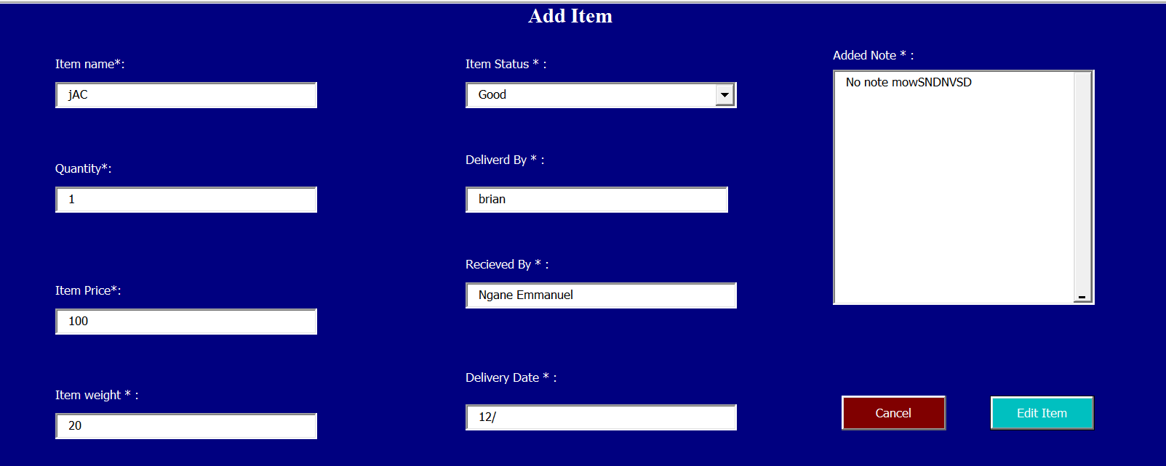

**Test** **Edit of items** : We see that upon selecting the row to be edited, the values are already predefined in the contextual menu that comes up, and we can modify any field we want. **Test passed**

**3.2.0 Subroutine 2 :**

**3.2.1 Objective: The objective of this test is to verify any item or fields can be modified.**

* 1. **Scope/Features:** Test modifying existing item details, verify changes are reflected in the inventory, test editing with invalid or missing data
  2. **Test cases/scenarios:**

**Case1:** edit item details

* 1. **Expected Result/actual:** Successful modification of item details and reflection shown in database

**Below are screenshots**

**3.5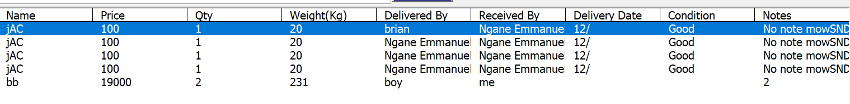3.6** 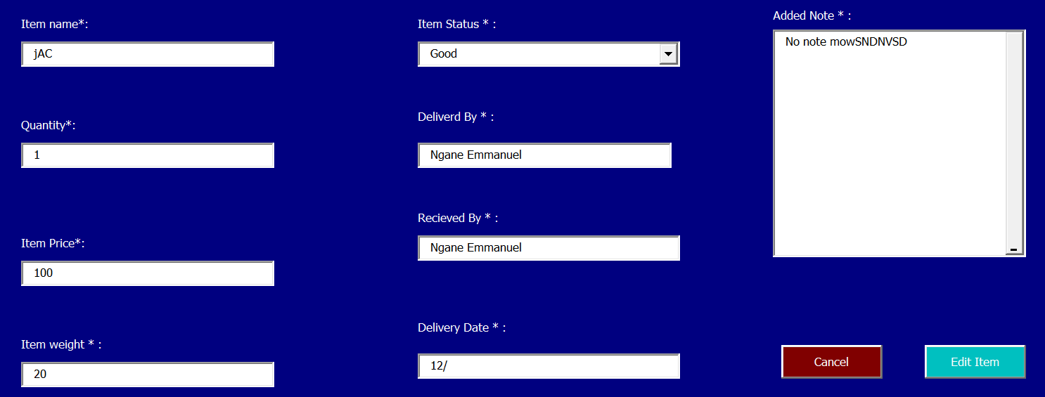

**Test reflection of the edit: Edited item shows up in the inventory**

**Passed.**

1. **Delete functionality:**

**4.0 Objective: T**he objective of this test s to verify that any item or record can be deleted from the database.

**4.0.1 Scope/features : T**est deleting an existing item, Verify item is removed from the database, Test deleting non-existent item.

* + 1. **Test Cases/scenarios:**
    2. **Case1: D**eleting an existing item
    3. **Expected result/actual result:** Item deleted successfully and its reflected in the database
    4. **Case2:** Deleting a non-existent item
    5. **Expected Result/actual: Select an item from database**

**Screenshots:**

**4.0.7**

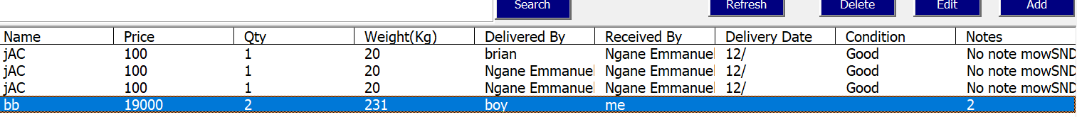

**4.0.7**

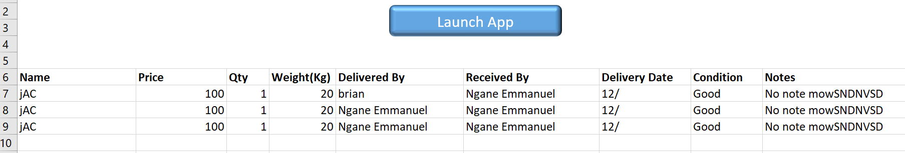

4.0.8

**Testing of deleting items:** System is designed such that the user must select an item to delete it. **Thus Test passed**

**Reflection of action in the inventory: Passed.**